Recursion

Recall that a recursive formula uses the preceding term(s) to define the next term. It is an example of an iterative process.

The following sequences are defined recursively. Write down the first five terms.

1. a1 = 2; an = 3 + an-1 2,5,8,11,16
2. a1 = 3; an = 4 - an-1 3,1,3,1,3
3. a1 = 1; a2 = 2; an = an-1 \* an-2 1,2,2,4,8
4. Let $u_{n}= \frac{({1+\sqrt{5})}^{n}- ({1-\sqrt{5})}^{n}}{2^{n}\sqrt{5}}$ be the nth term in a sequence
   1. Find *u1*and *u2* what do you notice? U1=1 U2=10/4sqrt(5)
   2. Now find the next 10 terms (you should have 12 total now)

1,1,2,3,5,8,13,21,34,55,89,144

* 1. Show that U3+2 = U3+1 + U3 5 = 3 + 2
  2. Do you know what this sequence is? Fibonacci Sequence
  3. What do you need to find the next term recursively not directly using the given formula? The two terms previous to the term you’re trying to find. Un-2 + Un-1 = Un

So now that you get recursion, let’s apply it to programming. You can actually re-write any loop using recursion. Here’s a recursive program to start with - what does this do?

def printnumber(n, max):

if n <= max:

print(n)

printnumber(n+1, max)

return

printnumber(0, 10)

Put the next two functions in the Python Visualizer and follow it. http://www.pythontutor.com/visualize.html#mode=edit

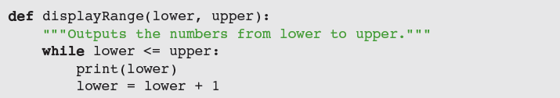

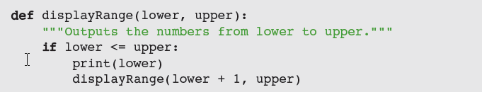

Go through the next two functions step by step. Use the Python Visualizer.

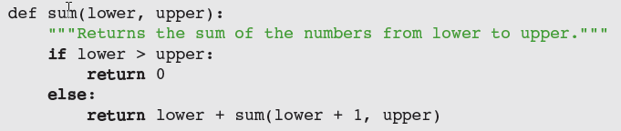

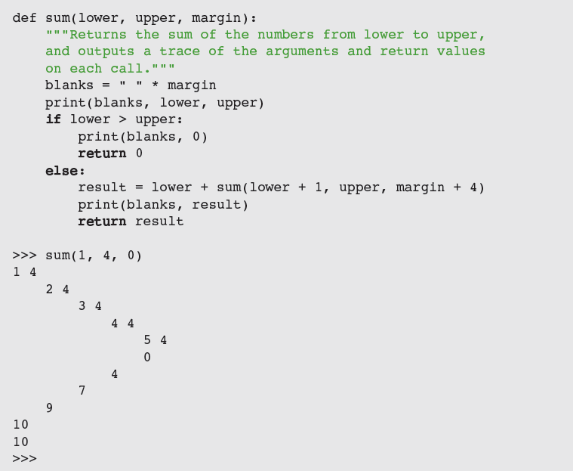

Remember recursion is when you have a function which calls itself.

P1: Now using the result from problem 4 above can you write a program that asks for n, the number of terms, and then recursively calls a function and prints out the nth term of the Fibonacci sequence? Can you print the first n terms?

P2: Next have the program write the nth term of the ratio $\frac{u_{n+1}}{u_{n}}$

As n gets large what does this ratio approach?

P3: Next have the program write the first nth term of the ratio $\frac{u_{n}}{u_{n+1}}$

As n gets large what does this ratio approach?

(This ratio is believed to have been used in the construction of the Great Pyramid in Egypt. The ratio equals the sum of the areas of the four face triangles divided by the total surface area of the great Pyramid. Just a fun fact to know and tell your friends.)

P4: Now write a program which sorts a list into numerical order. The catch: you can’t use sort or any of the library functions, and you have to use a recursive solution.